Flow configurations

==================================================================================

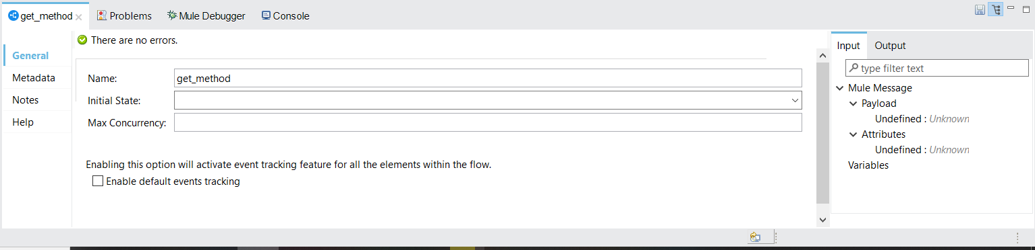

Name:- here we can define the what is the flow name

Initial State:- here we can set flow need to stop are start

Max Concurrency:- It is for threads allocations . suppose we give the value of 5

Implicit it duplicate the 5 same flows